APB SPI Project Pseudo Code & Report
Signal Description
Signal | Width | Direction | Signal Description
PCLK | 1 | Input | PCLK is a clock signal. All signals are timed against the rising edge of PCLK.
PRESET_n | 1 | Input | Active-Low Asynchronous Reset Signal.
PADDR_i | 3 | Input | Address bus APB (3 bits).
PSEL_i | 1 | Input | APB Slave Select Signal.
PENABLE_i | 1 | Input | PENABLE indicates the second and subsequent APB transfer cycles.
PWRITE_i | 1 | Input | PWRITE indicates an APB write access when HIGH, and an APB read access when LOW.
PWDATA_i | 8 | Input | The PWDATA is the write data bus.
PRDATA_o | 8 | Output | The PRDATA is the read data bus.
PREADY_o | 1 | Output | PREADY is used to extend an APB transfer by the Core.
PSLVERR_o | 1 | Output | PSLVERR is used to indicate an APB Transfer Error.
mosi_o | 1 | Output | MOSI (Master Out Slave In) is used to transmit data out of the SPI Core.
miso_i | 1 | Input | MISO (Master In Slave Out) is used to receive data into the SPI Core.
ss_o | 1 | Output | Slave Select is an active-low signal. Indicates that the slave peripheral has been selected when it is LOW.
sclk_o | 1 | Output | SCLK is used to output the clock with respect to which the SPI transfers data (Serial Clock).
spi_interrupt_request_o | 1 | Output | SPI Interrupt Request line to host.
RTL Module Connections
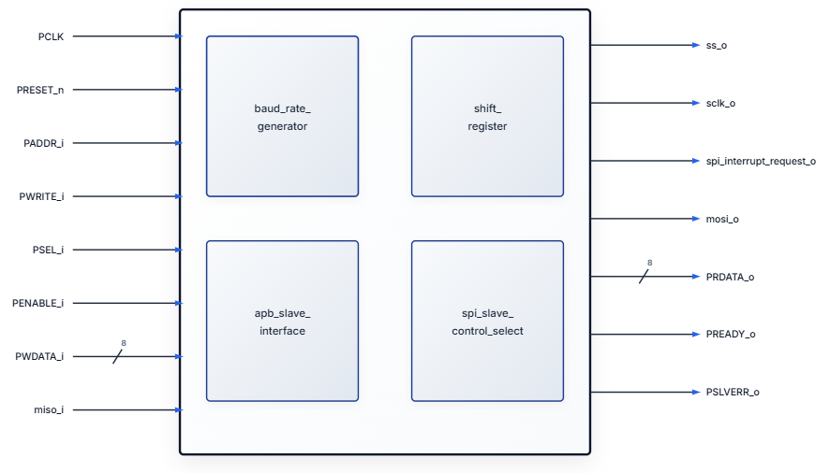
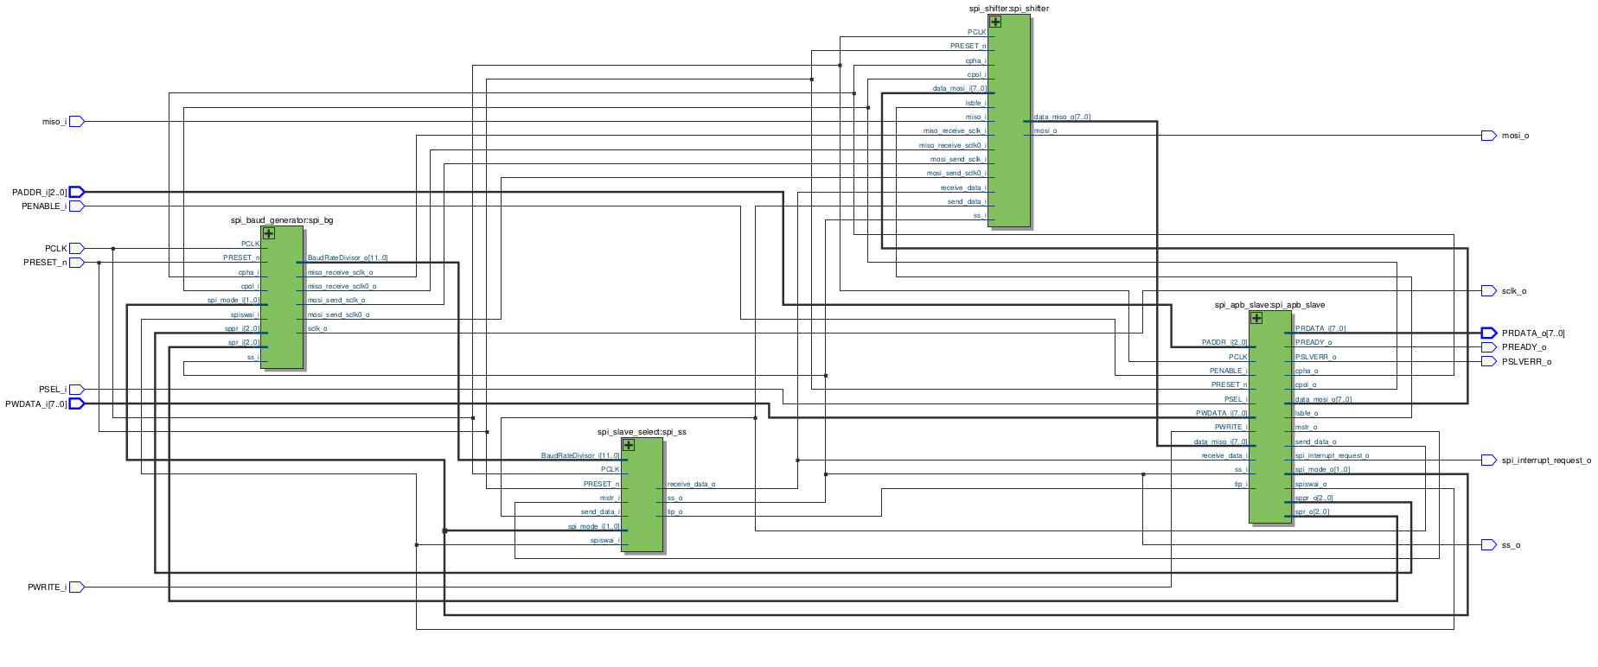
UVM TB Architecture
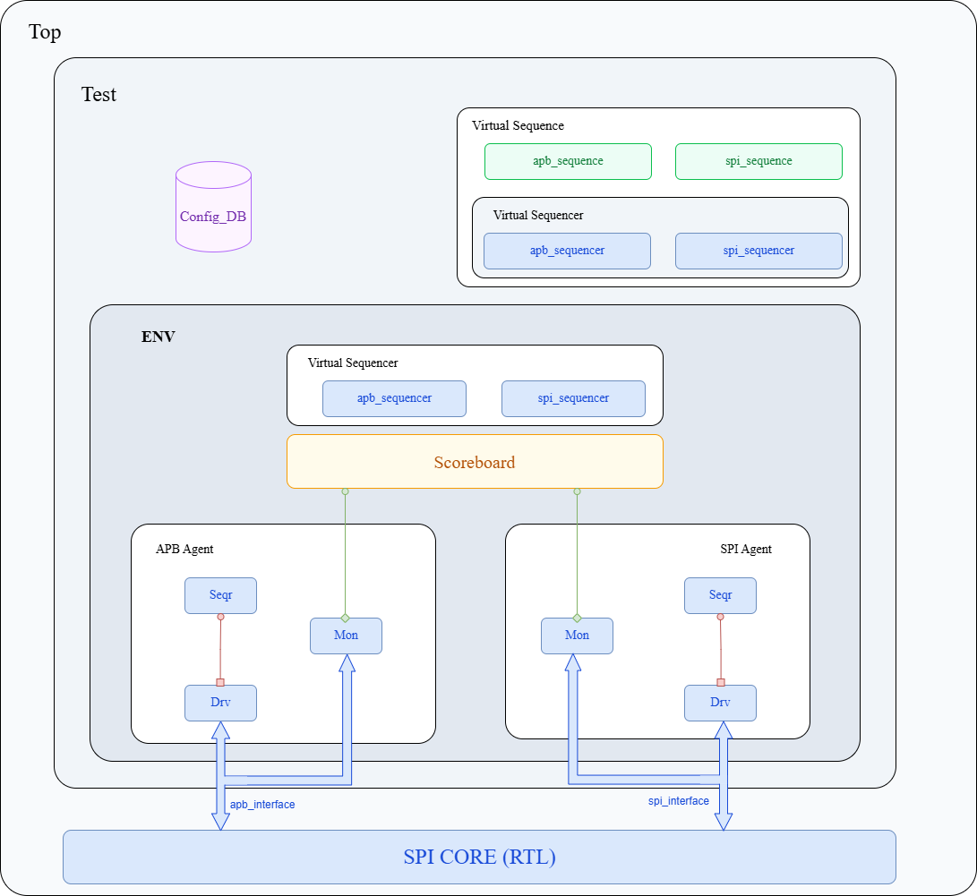

Baud Generator
1. Calculate the Clock Division Factor
- Goal: Continuously compute how many system clock (PCLK) cycles make up an SPI clock period.
- Logic: * Multiply the scale factor based on the primary rate selector (sppr_i + 1) by the exponential power of the secondary rate selector ($2^{\text{spr\_i} + 1}$).
  - Store this value as BaudRateDivisor_o.
2. Determine Initial Clock Polarity
- Goal: Set the default idle state of the SPI clock (SCLK).
- Logic: * If Clock Polarity (cpol_i) is High, set the idle state (pre_sclk_s) to High.
  - Otherwise, set the idle state to Low.
3. Generate the SPI Clock (SCLK)
- Goal: Toggle and manage the main SPI clock signal based on system states.
- Logic (On every system clock cycle or reset):
  - If a system reset occurs:
    - Reset the internal counter to 0.
    - Set SCLK to its idle polarity state.
  - Else if SPI is active (Slave Select is enabled, not in wait mode, and module status is RUN or WAIT):
    - If the counter reaches the half-way point of the clock divisor:
      - Invert (toggle) the SCLK signal to create the clock edge.
      - Reset the counter to 0.
    - Else:
      - Increment the counter by 1.
  - Else (SPI is idle/disabled):
    - Force SCLK back to its idle polarity state.
    - Reset the counter to 0.
4. Generate MISO (Receive) Sampling Flags
- Goal: Signal exactly when incoming data from the peripheral should be read.
- Logic (On every system clock cycle or reset):
  - If a system reset occurs, clear all MISO receive flags.
  - Else if SPI is active and configured for opposite CPOL and CPHA settings (Phase 1 mismatch):
    - Check if SCLK is High. If the counter hits the half-period mark, trigger the primary receive flag (miso_receive_sclk0_o). Otherwise, clear it.
  - Else if SPI is active and configured for matching CPOL and CPHA settings (Phase 0 alignment):
    - Check if SCLK is Low. If the counter hits the half-period mark, trigger the secondary receive flag (miso_receive_sclk_o). Otherwise, clear it.
  - Else (SPI inactive):
    - Ensure all MISO receive flags remain low/disabled.
5. Generate MOSI (Transmit) Timing Flags
- Goal: Signal exactly when outgoing data to the peripheral should be driven/shifted onto the line.
- Logic (On every system clock cycle or reset):
  - If a system reset occurs, clear all MOSI transmit flags.
  - Else if SPI is active and configured for opposite CPOL and CPHA settings:
    - Check if SCLK is High. If the counter is exactly 1 cycle away from the half-period mark, trigger the primary transmit flag (mosi_send_sclk0_o). Otherwise, clear it.
  - Else if SPI is active and configured for matching CPOL and CPHA settings:
    - Check if SCLK is Low. If the counter is exactly 1 cycle away from the half-period mark, trigger the secondary transmit flag (mosi_send_sclk_o). Otherwise, clear it.
  - Else (SPI inactive):
    - Ensure all MOSI transmit flags remain low/disabled.

SPI Slave Select
1. Calculate Transaction Target and Status Indicators
- Goal: Establish the total duration of a single 8-bit SPI transaction and tie the transfer status to the physical slave select line.
- Logic: * Multiply the BaudRateDivisor_i by 8 to determine the total number of system clock cycles (target_s) required to transmit a full byte.
  - Define the Transfer-in-Progress flag (tip_o) as the logical inverse of the Slave Select line (ss_o). When Slave Select is active (Low), Transfer-in-Progress is High.
2. Control Slave Select and Internal Receive Tracking
- Goal: Manage the timing of the hardware Slave Select signal and coordinate when a byte transfer finishes.
- Logic (On every system clock cycle or reset):
  - If a system reset occurs:
    - Set the cycle counter to its idle state (0xFFFF).
    - Deactivate the Slave Select line (set ss_o to High).
    - Clear the internal receive flag (rcv_s to Low).
  - Else if the module is in Master Mode, not in standby, and the operating mode is either RUN or WAIT:
    - If a request to send new data is detected (send_data_i is High):
      - Activate the Slave Select line (set ss_o to Low).
      - Reset the cycle counter to 0x0000 to start tracking the transaction.
    - Else if a transaction is ongoing (the counter hasn't reached the full 8-bit limit yet):
      - Keep the Slave Select line active (Low).
      - Increment the cycle counter by 1.
    - Else if the counter reaches the final clock cycle of the 8-bit transaction limit:
      - Raise the internal receive flag (rcv_s to High) to signal data completion.
      - Return the cycle counter to its idle state (0xFFFF).
    - Else (No active transfer and counter is idle):
      - Deactivate the Slave Select line (set ss_o to High).
      - Clear the internal receive flag (rcv_s to Low).
      - Force the cycle counter to stay at its idle state (0xFFFF).
  - Else (Module conditions not met / SPI disabled):
    - Force the cycle counter to its idle state (0xFFFF).
    - Deactivate the Slave Select line (set ss_o to High).
    - Clear the internal receive flag (rcv_s to Low).
3. Generate Output Receive Data Flag
- Goal: Create a registered output flag to notify the system that a full byte of data has been collected.
- Logic (On every system clock cycle or reset):
  - If a system reset occurs:
    - Reset the receive_data_o flag to Low.
  - Else:
    - Pass the value of the internal receive flag (rcv_s) to the registered output (receive_data_o). This introduces a 1-clock-cycle delay to stabilize the status indicator.

Shifter
1. Load Transmit Buffer (Shift Register)
- Goal: Capture parallel data from the system bus to prepare it for serial transmission.
- Logic (On every system clock cycle or reset):
  - If a system reset occurs:
    - Clear the transmit shift register to 0.
  - Else if a send request (send_data_i) is active:
    - Load the parallel input byte (data_mosi_i) into the transmit shift register.
2. Expose Received Data Output
- Goal: Control when incoming serial data collected from the peripheral is presented to the system bus.
- Logic: * If the receive indicator (receive_data_i) is active:
  - Drive the output bus (data_miso_o) with the contents of the temporary storage register (temp_reg).
  - Else:
    - Hold the output bus lines at zero (0x00).
3. Transmit Data Bit-by-Bit (MOSI)
- Goal: Shift out data serially over the MOSI line based on configured SPI modes and bit order.
- Logic (On every system clock cycle or reset):
  - If a system reset occurs:
    - Clear the mosi_o serial output line to 0.
    - Initialize the LSB-first counter to 0 and the MSB-first counter to 7.
  - Else if Slave Select is active (Low):
    - Evaluate SPI Mode settings (CPOL/CPHA):
      - Case A: Mixed configuration (Only one of CPOL or CPHA is high):
        - Monitor the primary transmit clock strobe (mosi_send_sclk0_i).
        - If configured for LSB-First: Shift out bits from index 0 to 7, incrementing the counter on each strobe. Reset counter after bit 7.
        - If configured for MSB-First: Shift out bits from index 7 down to 0, decrementing the counter on each strobe. Reset counter back to 7 after bit 0.
      - Case B: Aligned configuration (Both CPOL and CPHA match):
        - Monitor the secondary transmit clock strobe (mosi_send_sclk_i).
        - Run identical logic to Case A (handling LSB-first or MSB-first shifting) using this secondary timing strobe instead.
4. Receive Data Bit-by-Bit (MISO)
- Goal: Sample incoming serial data from the MISO line and reassemble it into a byte.
- Logic (On every system clock cycle or reset):
  - If a system reset occurs:
    - Clear the temporary receive buffer (temp_reg) to 0.
    - Initialize the LSB-receive counter to 0 and the MSB-receive counter to 7.
  - Else if Slave Select is active (Low):
    - Evaluate SPI Mode settings (CPOL/CPHA):
      - Case A: Mixed configuration (Only one of CPOL or CPHA is high):
        - Monitor the primary receive clock strobe (miso_receive_sclk0_i).
        - If configured for LSB-First: Catch the bit from the miso_i line and place it into temp_reg starting at index 0 up to 7, incrementing on each strobe.
        - If configured for MSB-First: Catch the bit from the miso_i line and place it into temp_reg starting at index 7 down to 0, decrementing on each strobe.
      - Case B: Aligned configuration (Both CPOL and CPHA match):
        - Monitor the secondary receive clock strobe (miso_receive_sclk_i).
        - Run identical logic to Case A (assembling the byte via LSB or MSB order) using this secondary timing strobe instead.

SPI Slave Select Interface Controller
1. Calculate Transaction Target and Status Indicators
- Goal: Establish the total duration of a single 8-bit SPI transaction and tie the transfer status to the physical slave select line.
- Logic: * Multiply the BaudRateDivisor_i by 8 to determine the total number of system clock cycles (target_s) required to transmit a full byte.
  - Define the Transfer-in-Progress flag (tip_o) as the logical inverse of the Slave Select line (ss_o). When Slave Select is active (Low), Transfer-in-Progress is High.
2. Control Slave Select and Internal Receive Tracking
- Goal: Manage the timing of the hardware Slave Select signal and coordinate when a byte transfer finishes.
- Logic (On every system clock cycle or reset):
  - If a system reset occurs:
    - Set the cycle counter to its idle state (0xFFFF).
    - Deactivate the Slave Select line (set ss_o to High).
    - Clear the internal receive flag (rcv_s to Low).
  - Else if the module is in Master Mode, not in standby, and the operating mode is either RUN or WAIT:
    - If a request to send new data is detected (send_data_i is High):
      - Activate the Slave Select line (set ss_o to Low).
      - Reset the cycle counter to 0x0000 to start tracking the transaction.
    - Else if a transaction is ongoing (the counter hasn't reached the full 8-bit limit yet):
      - Keep the Slave Select line active (Low).
      - Increment the cycle counter by 1.
    - Else if the counter reaches the final clock cycle of the 8-bit transaction limit:
      - Raise the internal receive flag (rcv_s to High) to signal data completion.
      - Return the cycle counter to its idle state (0xFFFF).
    - Else (No active transfer and counter is idle):
      - Deactivate the Slave Select line (set ss_o to High).
      - Clear the internal receive flag (rcv_s to Low).
      - Force the cycle counter to stay at its idle state (0xFFFF).
  - Else (Module conditions not met / SPI disabled):
    - Force the cycle counter to its idle state (0xFFFF).
    - Deactivate the Slave Select line (set ss_o to High).
    - Clear the internal receive flag (rcv_s to Low).
3. Generate Output Receive Data Flag
- Goal: Create a registered output flag to notify the system that a full byte of data has been collected.
- Logic (On every system clock cycle or reset):
  - If a system reset occurs:
    - Reset the receive_data_o flag to Low.
  - Else:
    - Pass the value of the internal receive flag (rcv_s) to the registered output (receive_data_o). This introduces a 1-clock-cycle delay to stabilize the status indicator.

UVM Test Bench Pesudo content
1. apb_spi_pkg.sv
- Role: Serves as the central compilation anchor for the entire verification ecosystem.
- Logic: Imports the base UVM definitions and macros to establish the standard object library baseline.
  - Compiles transaction descriptors, structural configurations, physical agents, tracking modules, and top-level execution sequences into a single unified scope to streamline asset availability throughout the hierarchy.
2. Hardware Verification Top Component (top.sv)
- Role: Establishes the physical hardware testbench container, grounding the clock distribution networks and linking the simulation framework to the Design Under Test (DUT).
- Logic:
  - Generates the primary simulation clock source utilizing a continuous, symmetric free-running toggle loop.
  - Instantiates the core hardware block alongside its peripheral boundary connections, tying specific APB and SPI physical logic lines to their respective controller pins.
  - Publishes concrete handles of the physical bus lines into the central database lookup registry, allowing abstract verification components located deep within the environment to dynamically discover and attach to the hardware pins.
3. Verification Signaling Interfaces (apb_if.sv & spi_if.sv)
- Role: Encapsulates the pin-level signals for the dedicated buses, transforming naked wire waveforms into synchronized, race-condition-free data windows for software components.
- Logic:
  - Grouping distinct functional signal bundles for execution tracking: the parallel register control port (address, select, control, write-data, read-data) and the serial transfer port (serial clock, slave select, peripheral out, peripheral in).
  - Implements separate time-sampled synchronization blocks (Clocking Blocks) to separate driving operations from monitoring operations:
    - Driver Gateways: Configure dedicated output-driving directions to allow the software to safely inject values on target signal pins relative to edge alignments.
    - Monitor Gateways: Establish passive, read-only capture windows to accurately sample signal levels without interfering with the physical bus state.
  - Projects specialized architectural access windows (Modports) to strictly enforce directional signal contracts on active and passive tracking components.
4. Coordination Routing Hub (apb_spi_virtual_sequencer.sv)
- Role: Acts as an abstract, zero-pin routing engine designed to centralize stimulus orchestration across multiple independent protocol interfaces.
- Logic:
  - Avoids managing raw transaction item streams directly, serving instead as a structural container for lower-level sequencers.
  - Queries global topology settings dynamically during system assembly to determine the required size for sub-system targeting arrays.
  - Allocates and maintains arrays of placeholder handle sockets for the physical APB and SPI sequencers, laying down the underlying structural routing tracks used by complex test scenarios.
5. Multi-Protocol Scenario Coordinator (apb_spi_virtual_seqs.sv)
- Role: Orchestrates the high-level cooperative interaction patterns between independent bus subsystems by governing lower-level sequences.
- Logic:
  - System Discovery Layer: Retrieves operational layout dimensions from the central database to dynamically configure its internal tracking handles.
  - Routing Anchor Mapping: Discovers its parent virtual sequencer component, executing a runtime safety verification check to confirm system structural alignment. Upon validation, it resolves internal references, connecting its local sequencer handles directly to the active hardware routing sockets.
  - Test Scenario Coordination (apb_write_read_vseq): Encapsulates high-level verification recipes by instantiating targeted sub-sequences (such as register configuration routines and subsequent validation read routines). It directs their execution sequentially on specific target sequencer lines to create coordinated multi-bus transaction flows

5. Verification Test Base Pattern (apb_spi_test inside apb_spi_test.sv)
- Role: Establishes the foundational parent execution block responsible for initializing structural properties, publishing configuration objects, and building the environment.
- Logic:
  - Configuration Construction: instantiates top-level environment configurations and automatically sets up structural agent sizing matrices based on initial settings.
  - Interface Pin Resolution: Creates separate device interface sub-configurations, automatically retrieving live virtual interface signal pins from the central database and packing them safely into down-stream configuration structures.
  - Environment Publishing: Saves the finished structural configurations into the central database lookup registry before instantiating the top-level verification container module.
6. Specialized Scenario Derivatives (Derived Tests inside apb_spi_test.sv)
- Role: Implements custom stimulus rules, protocol combinations, and runtime sequences to systematically verify specific areas of the design.
- Logic:
  - Hardware Initialization Sequence (apb_reset_test): Leverages base setup logic, overrides the execution phase, raises execution objections, and drives specialized hardware initialization operations on the primary control sequencer to reset the DUT.
  - Protocol Phase/Polarity Variant Checkers (apb_000_test through apb_111_test): Publishes unique, specific 8-bit mode control bytes into the configuration lookup database. During execution, they sequence targeted configuration transfers and subsequent validation read streams to evaluate the design under every possible clock phase, clock polarity, and data shifting orientation.
  - Asynchronous Peripheral Injection (spi_miso_test): Bypasses the host interface initially to execute an independent stimulus routine directly on the serial peripheral sequencer, filling up the design's internal channels before launching a delayed host read validation phase.
  - Coordination-Driven Validation Sequence (apb_vtest): Creates an abstract multi-protocol test scenario by establishing a virtual sequence handle, pushing a multi-protocol control byte down to the database, and initiating the coordinated virtual sequence straight to the virtual sequencer routing engine

7. Global Environment Configuration Block (apb_spi_env_config.sv)
- Role: Acts as the primary structural blueprint for the verification environment, storing architectural control properties in a central location.
- Logic:
  - Defines topology-mapping parameters to determine whether active testbench clusters (such as APB agents, SPI agents, scoreboards, and virtual routing hubs) should be constructed.
  - Hosts arrays of independent config sub-handles to easily pass distinct interface parameters downward through the testbench hierarchy.
8. Central Verification Container (apb_spi_env.sv)
- Role: Serves as the ultimate hardware-independent structural parent component, responsible for assembling, structuring, and connecting the sub-system verification clusters.
- Logic:
  - System Construction Layer: Retrieves the environment configuration blueprint from the central data lookup registry. It checks structural control parameters to dynamically allocate and build the APB and SPI sub-environments, validation checkers, and coordination sequencers.
  - Analysis Interconnection Gateway: Iterates through active sub-environment agent matrices to automatically link passive observation monitoring ports directly to dedicated analytical checking storage channels within the checking scoreboard.
  - Stimulus Routing Alignment: Inspects topology configuration parameters to automatically resolve physical sequencer routing handles, wiring sub-component sequencers up to placeholder tracking arrays inside the virtual sequencer hub.

APB SECTION
1. APB Data Transaction Profile (apb_trans.sv)
- Role: Encapsulates the abstract data model and bus attributes for a single APB host transaction.
- Logic:
  - Defines randomizable data members for the primary control signals, including write-enable flags, transaction address vectors, and write-data payloads.
  - Maintains un-randomized state variables representing physical peripheral responses, such as ready flags, bus errors, and captured read data.
  - Extends the custom representation interface to visually map and print transaction properties across standard binary fields during tracking phases.
2. APB Protocol Sequence Collections (apb_seqs.sv)
- Role: Governs the creation and runtime generation of structured transaction item sequences directed toward the host interface.
- Logic:
  - Configuration Scenario Loop (apb_cpol_cpha_lsbfe_seqs): Queries a specific mode control byte from the lookup database. It uses a synchronized protocol loop to generate a sequence of randomized transaction objects: executing a dummy read cycle first, followed by consecutive, directed write operations to systematically populate peripheral control registers, bit-rate scale units, and data buffers.
  - System Reset Scenario Loop (apb_reset_seqs): Constructs consecutive transaction elements targeted at default register mappings, enforcing active-low reset parameters across all configurations to restore the device to its default startup state.
  - Bus Validation Read Loop (apb_read_seqs): Builds a sequence of read operations to targeted memory mappings, instructing the driver to collect and verify register contents.
3. APB Sub-System Environmental Cluster (apb_agent_top.sv)
- Role: Acts as the high-level structural container that aggregates and instantiates the complete array of APB interface agents.
- Logic:
  - Extracts structural topology data from the primary environment configuration object.
  - Dynamically allocates and handles child agent arrays based on required sub-system capacities.
  - Iterates through the active cluster structure to provision sub-agent configurations and construct active physical verification agents hierarchically.
4. APB Physical Interface Agent (apb_agent.sv)
- Role: Encapsulates the core driving, sequencing, and monitoring sub-components for a dedicated APB bus instance.
- Logic:
  - Retrieves dedicated local agent configurations from the central database to check operational profiles.
  - Instantiates the passive interface observer component unconditionally to guarantee continuous transaction capturing.
  - Evaluates active status properties dynamically: if configured as an active executor, it constructs the protocol sequencer and physical line driver, then wires their communication paths together during the alignment phase.
5. APB Configuration Routing Hub (apb_sequencer.sv)
- Role: Operates as the dedicated transaction broker, matching inbound sequence streams to the physical driver interface.
- Logic:
  - Inherits core FIFO arbitration and buffering capabilities tailored for APB transaction types.
  - Manages communication requests between abstract scenario algorithms and active physical hardware executors without directly processing physical signal pins.
6. APB Physical Pin-Level Driver (apb_driver.sv)
- Role: Directs active pin operations, translating abstract software transaction objects into physical waveforms on the APB interface.
- Logic:
  - Resolves and maps local virtual interface handles from its agent configuration structure.
  - Hardware Reset Protocol: Aligns with the driving clock edge to assert the active-low hardware initialization line for a predefined period before releasing it back to a stable high state.
  - Bus Waveform Drive Protocol: Processes transactions continuously by pulling incoming items from the sequencer port. It injects address vectors and write-enable states onto physical lines, manages setup cycle delays, establishes high-impedance windows for write data, activates select/enable lines, waits for peripheral response flags, samples target data buses on read cycles, and clears interface lines back to idle when complete.
7. APB Passive Interface Monitor (apb_monitor.sv)
- Role: Sniffs the physical APB lines passively to reconstruct clear transaction objects and broadcast them for validation checking.
- Logic:
  - Connects directly to the passive monitor virtual interface via local agent configurations.
  - Executes a continuous sniffing loop that blocks until the peripheral interface signals an active data-ready cycle.
  - Captures the status of control lines, write indicators, and address lines. If a write operation is active, it extracts the data payload from the write bus; for read operations, it gathers the peripheral response payload and status lines.
  - Bundles the assembled properties into a clean transaction packet, prints a summary to the tracking logs, and publishes the item through the analysis port to the scoreboard before returning to the capture loop.

SPI SECTION
1. SPI Data Transaction Profile (spi_trans.sv)
- Role: Models the abstract data properties and signal representations for a single serial SPI transaction.
- Logic:
  - Defines a randomizable data vector representing incoming peripheral data driven onto the MISO line.
  - Tracks static state variables capturing design outputs from the serial interface, including the serial clock line, slave select line, and the captured output data vector.
  - Intersects with the standard printing facility to format and render the active states of the serial bus signals into descriptive binary fields.
2. SPI Peripheral Sequence Collections (spi_seqs.sv)
- Role: Controls the generational rules and stimulus patterns directed toward the peripheral serial interface.
- Logic:
  - Peripheral Response Loop (spi_miso_seqs): Implements a dedicated generation loop that instantiates an isolated serial transaction item. It locks down a specific, predefined 8-bit response pattern for the peripheral line and passes the item to the execution plane to simulate design interaction.
3. SPI Sub-System Environmental Cluster (spi_agent_top.sv)
- Role: Serves as the structural sub-environment parent tasked with establishing the physical array layout of SPI agents.
- Logic:
  - Pulls the primary configuration database reference to discover the layout dimensions of the peripheral sub-system.
  - Dynamically allocates structural array elements matching the targeted component count.
  - Loops over the topology map to hand off specific child configurations into the local lookup database before dynamically instantiating individual SPI agents.
4. SPI Physical Interface Agent (spi_agent.sv)
- Role: Chains together the sequencer, physical line driver, and passive stream observer into a cohesive protocol component.
- Logic:
  - Looks up local interface constraints and operational types from the central database.
  - Construct the passive monitor component unconditionally to maintain observation continuity.
  - Examines the operational enum setting: if designated as active, it creates both the serial transaction sequencer and physical driver, then establishes the transaction port-to-export connectivity link.
5. SPI Configuration Routing Hub (spi_sequencer.sv)
- Role: Serves as the protocol-specific arbitration node that routes serial stimulus vectors to the hardware interface.
- Logic:
  - Provides fundamental sequence tracking, item storage queues, and handshake mechanics specifically optimized for serial transaction packets.
6. SPI Physical Pin-Level Driver (spi_driver.sv)
- Role: Manages the active translation of software transactions into timed bitstream transitions on the physical MISO line.
- Logic:
  - Resolves virtual interface connectivity using localized database config settings.
  - Establishes a continuous processing loop that fetches items from the sequencer, queries the active protocol control byte from the test database, and extracts mode modifiers (Clock Polarity, Clock Phase, and Bit Shifting Direction).
  - Evaluates the hardware Select line, stalling execution until an active-low select state is visible on the bus.
  - Selects a dedicated timing path by evaluating the structural constraints:
    - Bit Order Evaluation: Directs data via an incremental sequence (Index 0 to 7) for LSB-First configurations, or via a decremental sequence (Index 7 down to 0) for MSB-First configurations.
    - Clocking Mode Evaluation: Synchronizes bit shifts to the physical clock lines based on standard mode rules. It either injects the initial bit immediately and toggles subsequent indices on falling edges (Mode 00) , drives updates exclusively on rising edges (Mode 01 or Mode 10) , or updates values on falling edges after the initial boundary transition (Mode 11).
7. SPI Passive Interface Monitor (spi_monitor.sv)
- Role: Passively sniffs the serial lines to track protocol states, reassemble serial bits into bytes, and publish completed items.
- Logic:
  - Maps its internal observation lines directly to the passive modport of the SPI virtual interface.
  - Executes a continuous tracking loop that extracts current clocking parameters from the configuration database on every cycle.
  - Monitors the hardware select line, waking up when an active transaction window opens.
  - Tracks individual clock transitions through a loop to accurately sample both the MISO and MOSI data lines:
    - LSB Mode Tracking: Samples bits on consecutive rising edges (Modes 00/11) or falling edges (Modes 01/10) and places them into the transaction array from index 0 up to 7.
    - MSB Mode Tracking: Reverses the assembly target, placing incoming data samples from index 7 down to 0 using the identical clock-edge selection rules.
  - Upon collecting a full 8-bit transfer, it captures the current clock state, sends a detailed summary to the verification log, and pushes the transaction object through the analysis port to the scoreboard

SCOREBOARD
1. Streamlined Data Checker (apb_spi_scoreboard.sv)
- Role: Manages the active dual-stream storage pipelines to evaluate data integrity across protocol boundaries.
- Logic:
  - Processing Infrastructure: Instantiates separate transaction channels to intercept incoming host packets and serial peripheral packets concurrently.
  - Write Validation Loop: Compares active host write payloads targeted at the primary peripheral data buffer address with the serial bitstreams collected on the active transmission line.
  - Read Validation Loop: Compares parallel read response payloads driven back onto the host bus with the serial bitstreams captured from the peripheral response line.
  - Summary Metrics: Tallies final simulation match counts against transaction anomalies to generate an ultimate health report for the verification environment.
2. Functional Coverage Metric Blocks
- Role: Establishes structural measurement targets to guarantee thorough exposure of the design's interface states.
- Logic:
  - Host Coverage Group (apb_cover_group): Logs state tracking across fundamental host control signals, mapping reset boundaries, transaction handshake vectors, bus access indicators, and address selections. Payloads are divided into low-range and high-range numeric partitions, while structural cross-coverage tracks concurrent multi-signal handshake states.
  - Protocol Coverage Group (spi_cover_group): Tracks the framing boundaries of the peripheral select line and captures low/high numeric pay-load distributions across both serial transmission vectors.
3. Interface Protocol Assertions (SVA)
- Role: Implements formal, cycle-accurate temporal rules tied to the clock edge to validate bus protocol compliance and trap physical signaling violations immediately.
- Logic:
  - Control & Address Stability Tracker: * Guarantees that write indicators, target address vectors, and payload data lines remain completely fixed from the moment the host interface select line rises until the peripheral asserts its data-ready acknowledgment.
    - Monitors the phase enablement line, ensuring that the host selection and phase properties do not fluctuate while a transaction cycle is outstanding.
  - Handshake and Timing Windows: * Ensures that when selection and phase lines are concurrently high, a valid data-ready acknowledgment will inevitably arrive within a finite window.
    - Validates that the data-ready line remains low during the initial setup cycle (when select is high but enable has not yet risen).
  - Boundary and Safety Violations: * Constrains address lookups to confirm that the host never issues transactions to reserved peripheral address map spaces.
    - Enforces interface deassertion contracts, ensuring that both the phase enablement line and the data-ready line immediately drop to a inactive state whenever the host unselects the peripheral.
  - Data Integrity Triggers:
    - Intercepts valid write cycles to verify that no high-impedance or uninitialized states leak onto the write data lines during a transfer.
    - Intercepts valid read cycles to verify that the peripheral drives stable, valid logic levels onto the return data lines during an active read window.

